**Unit 5 - Lab 2**

**Friction**

1. 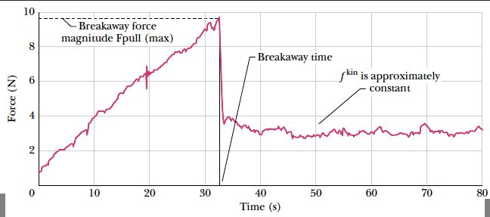Be sure that you get a graph similar to the one below before keeping your data and recording your values on the table below.

F⊥

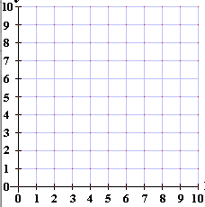

|  |  |  |
| --- | --- | --- |
| **F⊥**  **(N)** | **F*f*static (N)** | **F*fkinetic* (N)** |
|  |  |  |
|  |  |  |
|  |  |  |
|  |  |  |
|  |  |  |
|  |  |  |
|  |  |  |
|  |  |  |
|  |  |  |

1. Determine the slope of the line for the kinetic (moving) Friction Force. (Show your work)
2. Determine the slope of the line for the static (stationary) Friction Force. (Show your work)
3. Why is there a difference between the static value and the kinetic value?
4. Based on your experiment, what values are possible for the *static* Force of Friction for a given Normal Force? Why is there not just one value, like in the kinetic case?